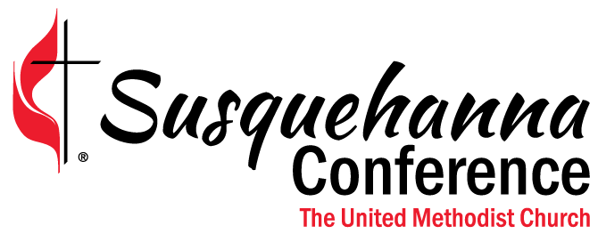
MISSION: “Making disciples of Jesus Christ
for the transformation of the world”
VISION: Encourage, Equip, Empower, Everyone to Reach, Teach and Serve
State College District

August 20, 2021
Dear Friends,
Thank you for attending the MissionInsite Training this past week with Chuck Salter. The training was recorded which will give you the opportunity to review and share with your leaders and the church. As, I have shared with you through emails and cluster gatherings, you will be using MissionInsite in preparation for your Charge Conference this year.
I am attaching a MissionInsite Guide for Charge Conferences for you to use this year and the QuickInsite Worksheet. In this letter is more detail for you to use with your church leadership as a guide for what my District expectations will be for Charge Conferences. Please keep in my mind, I do not want to make the Charge Conference "assignment" cumbersome, but eye-opening enough that church leadership will want to share their findings. Some of you may choose to do more for the CC and some of you may choose to do just what is asked. All the information will be beneficial.

1. Share the QuickInsite guide and/or worksheet with individuals on your leadership team to complete before you meet as the leadership team in preparation for Charge Conference.

2. At the leadership team meeting, discuss and compare Quickinsite. Provide copies (or have individuals provide their own) Mission Insite Report. After guiding the leadership team through the report, answer the following questions:

- From the information on Mission Insite, what are three significant concerns in our community?

1.

2.

3.

- From the information on Mission Insite, what mosaic groups are we already reaching with our current ministries?

- From the information on Mission Insite, what mosaic groups are we missing?

- Of the mosaic groups we are missing, choose ONE that could be our focus in the coming months.

- Begin to pray and brainstorm ways to discover (not assume) more about our community in general and this focus group. How can we discover what the needs may be rather than assume we know? What community groups might we be able to collaborate with? How might we be able to initiate conversations with neighbors?

Ideas:
- Prayer walk or drive the community asking God to help us “see” what we’ve never noticed before.
- Strike up that first conversation. Find common ground. Begin conversation with the said group ask questions to help you better understand their needs, their life. Meet them where they are, do not “overdo church on them.”
- Ask to go for a walk. Begin to build relationships. Individuals in the church who live near people in the focus group can begin steps to be a neighbor.
- Host a gathering on the front lawn. At your home would be ideal.

5. Present summary and findings to the Charge Conference.
6. Within the next year, develop a plan to reach this focus group.
6. Within the next year, begin to integrate more leadership teams into using the Mission Insite information for their areas of focus.

Together on the journey,

Rev. Brenda K. Leigey
State College District Superintendent
Susquehanna Conference of The United Methodist Church

Together
Growing Spiritual, Transformational Leaders,
Equipping Congregations for Vitality & Creating New Places for New People, and
Connecting with Each Other and the World

